01.06.2025

AGH, Signals and Systems Krzysztof Smykla

**Lab Assignment 4  
Report**

**Problem 1** – **FIR filter design using Fourier series:**

**Task 4.1. –** Using the fourier series method, design a length-15 FIR lowpass filter to approximate an ideal lowpass filter with Ω = 0.3π rad:

1. **Calculate and plot h[n] using Matlab:**

The finite impulse response h[n] is given by the formula below:

where **n** is an array of length 15.

The corresponding plot is presented below.

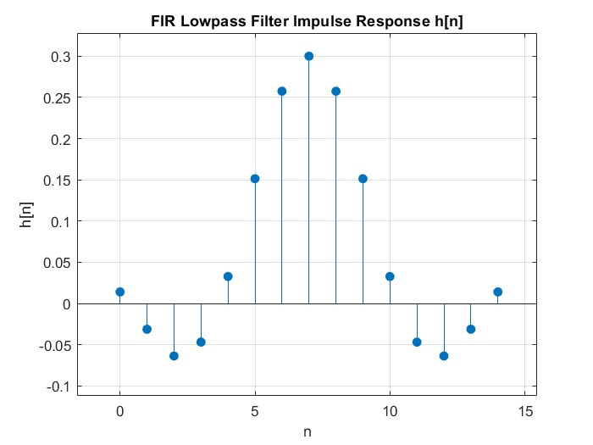  
Fig. 1

1. **Calculate H[Ω] using fft in Matlab:**

H[Ω] represents the magnitude response of the FIR filter. It is calculated based on the built-in fft(h, n) function in Matlab where h is the finite inpulse response and n is the number of samples.

1. **Plot H[W] using Matlab:**

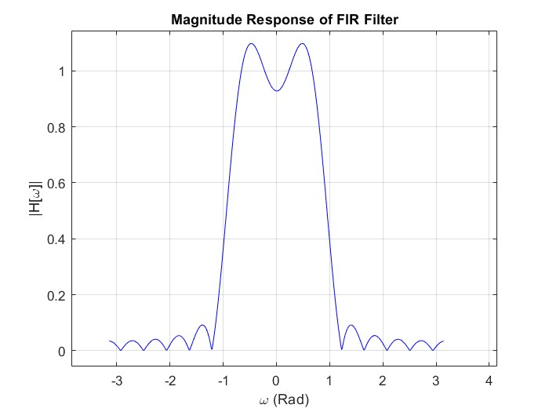  
Fig. 2

**Problem 2** – **Fourier series design using window functions:**

**Task 4.2:** Design a length-15 FIR lowpass filter to approximate an ideal lowpass filter with Ωc = 0.3π rad. Use Hamming and Blackman windows for two separate designs.

Window functions are mathematical functions which are zero-valued outside of some given interval. Typically, window functions are symmetric around the middle of a given inerval and are used in signal processing to reduce the phenomenon of spectral leakage, which is characterized by the creation of unexpected frequency components as a result of a transformation. An example of spectral leakage during sampling is known as ailiasing which occurs when a singal is sapled at a rate less than double the Nyquist frequency.

1. The **Hamming window** coefficients resulting from applying the window given by the equation below to the FIR lowpass filter:

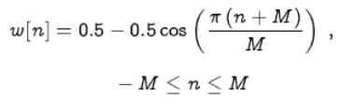

**Hamming window coefficients w[n]:**

w[n] = { 0, 0.0495, 0.1883, 0.3887, 0.6113, 0.8117, 0.9505, 1.0000, 0.9505, 0.8117, 0.6113, 0.3887, 0.1883, 0.0495, 0 }

Fig. 3

1. The **Blackman window** coefficients resulting from applying the window given by the equation below to the FIR lowpass filter:

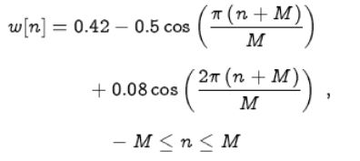

**Blackman window coefficients w[n]:**

w[n] = { 0.0000, 0.0194, 0.0905, 0.2367, 0.4592, 0.7139, 0.9204, 1.0000, 0.9204, 0.7139, 0.4592, 0.2367, 0.0905, 0.0194, 0.0000}

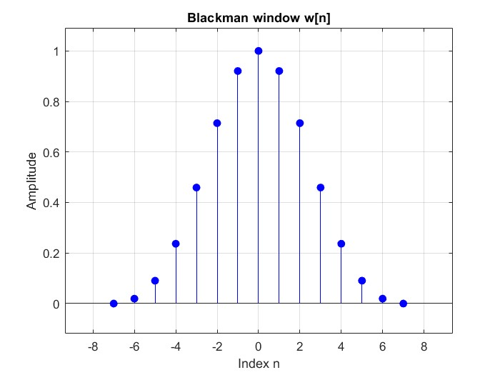Fig. 4

The resulting plots are identical to the ones shown in the problem description.

**Task 4.2.1:** Calculate and plot h[n] truncted with:

1. Rectangular window

2. Hamming window

3. Blackman window

* Calculate the respective H[W] using fft
* Plot obtained results
* Compare amplitude responses of the designed filers, comment differences.

The plots of signal h[n] truncated by different windows are presented below:

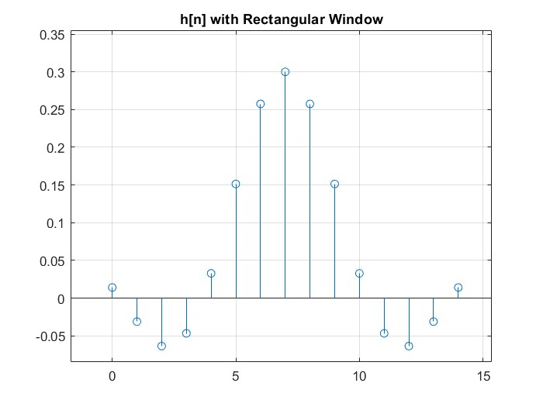  
Fig. 5

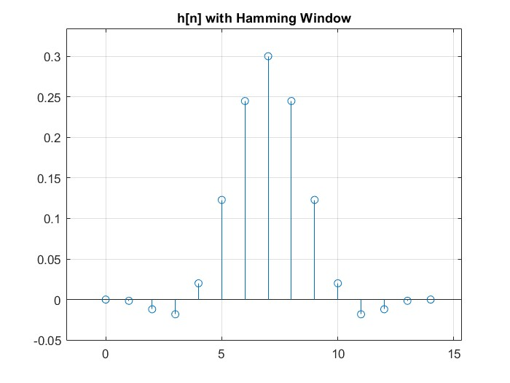  
Fig. 6

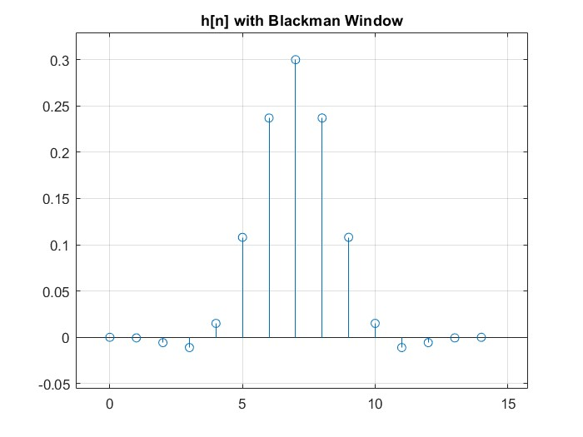  
Fig. 7

The corresponding plot shows the **amplitude response** for each of the corresponding window functions.

Below is a summary of the main characteristics and trade-offs of the different window functions.

**Rectangular Window:**

* Amplitude Response: Has large ripples in the stopband (high side lobes).
* Effect: More unwanted frequencies pass through.
* Trade-off: Sharp cutoff, but poor stopband attenuation.

**Hanning Window:**

* Amplitude Response: Smaller ripples than rectangular window.
* Effect: Better at reducing unwanted frequencies.
* Trade-off: Smoother response with moderate sharpness in the transition band.

**Blackman Window:**

* Amplitude Response: Very low ripples (lowest side lobes).
* Effect: Excellent at suppressing unwanted frequencies.
* Trade-off: Transition from passband to stopband is slower (wider).

**Problem 3** – **FIR filter design using Matlab’s FIR Filter Design functions:**

**Task 4.3:** Using the Fourier series method, design length-71 FIR LP filters to approximate ideal lowpass filters with Ωc = 0.3π rad using different windows.

**FIR Filter Design (Length 71,** Ωc **= 0.3𝜋):**

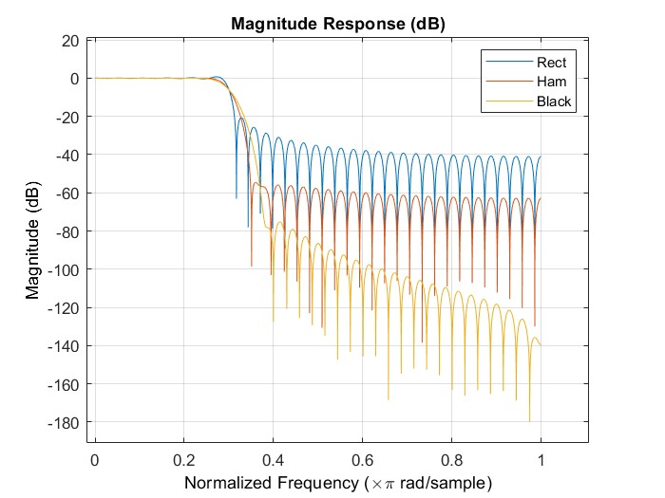Fig. 8

**Interpretation: What do you gain or lose using different windows?**

| **Window** | **Gain** | **Loss** |
| --- | --- | --- |
| Rectangular | Narrowest transition band (sharper cut) | High side-lobe ripple (poorer stopband) |
| Hamming | Good side-lobe attenuation | Slightly wider transition band |
| Blackman | Best stopband attenuation (lowest ripple) | Widest transition band |

**What is gained by increasing filter length from 15 to 71?**

* **Better frequency resolution**: Narrower main lobe (sharper cutoff).
* **Improved stopband attenuation**: More filter taps allow better approximation of ideal response.
* **Reduced leakage**: Longer filters allow for smoother transitions and lower side lobes.

However:

* **Cost**: Increased computation and delay (longer filters = higher latency).

**Summary:**

This report explores various methods for designing Finite Impulse Response (FIR) filters. One approach involves applying the Fourier transform to the ideal impulse response to determine the filter characteristics. Alternatively, windowing techniques—such as the Rectangular, Hamming, and Blackman windows—can be used to truncate and shape the impulse response, improving the practical performance of the filter. These windows help control trade-offs between sharpness of cutoff and stopband attenuation. The window functions can be implemented manually or accessed using MATLAB’s built-in tools for efficient design.